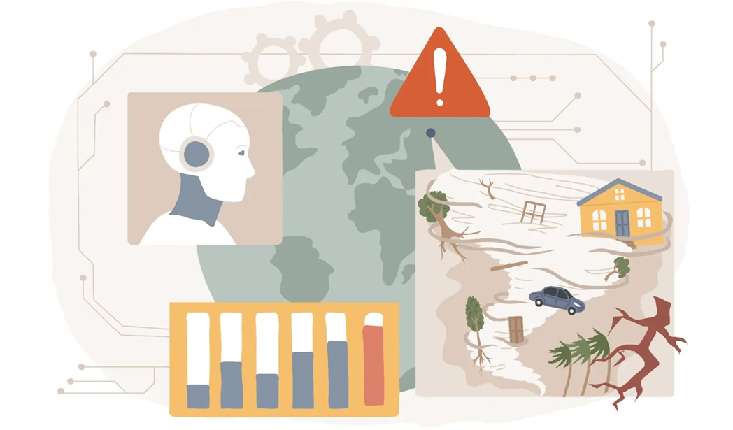
Domain Understanding
Crisis Help Classification
Slavova,Katerina K.S.
2025

Contents
Introduction 2
Red Cross 2
Doctors Without Borders 3
Similar Tools 4
Artificial Intelligence for Digital Response 4
Red Cross 510 5
Resources 5

Introduction
The goal of this project is to develop an AI Crisis Help Classification system that analyzes a disaster-related text message and predicts which humanitarian needs apply to each message. The labels include intent (request or offer of help), needs (shelter, water, food, medical help, etc.) and contextual labels such as disaster type. A single message can belong to multiple labels, which is why this task is formulated as a multi-label text classification problem.

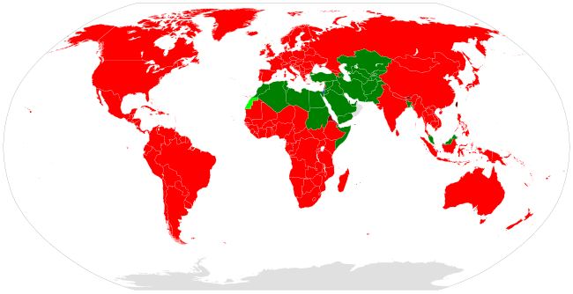
Red Cross

The International Federation of Red Cross and Red Crescent Societies (IFRC) is the world’s largest humanitarian network with around 16 million volunteers worldwide. Its main goal is to protect human life and health and to ensure respect for all individuals. The organization is guided by 7 fundamental principles – humanity, impartiality, neutrality, independence, voluntary service, unity and universality – all intended to build trust in people and ensure the Red Cross would not take sides in conflicts and would treat each individual with the same respect.
Nowadays, the Red Cross provides several methods for people to contact them – website contact forms, telephone hotlines and emails (all differ for each country). On 20th April 2025, the American Red Cross opened a new Digital Operations Center, which aims to help the organization use social media to solve various humanitarian issues. The employees working for the center monitor an average of 5,000 to 7,000 posts plus additional ones not related to the organization. In an interview, the Junior Director of Social Engagement states that their internal team is focused on 4 main tasks – social listening, finding people who need help or information, replying and providing help, storytelling and building long-term relationships. This illustrates how much manual effort is required right now to analyze and interpret social media content and emphasizes the need for an AI solution that can classify messages, allowing staff to focus their time and effort on the crucial cases.

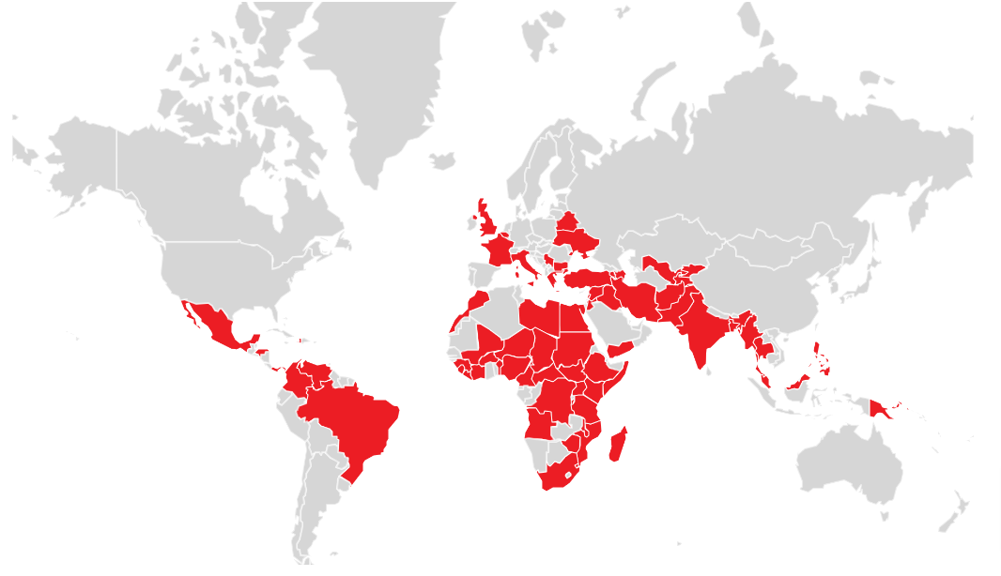
Doctors Without Borders

Médecins Sans Frontières (MSF), also known as Doctors Without Borders, is an International, independent medical humanitarian organization. MSF provides medical help to individuals affected by conflicts, disasters, epidemics or exclusion from healthcare. Currently, their team consists of more than 67,000 professionals from the medical, logistics, administration, communication and skilled trades fields, and they work in 75 countries. All guided by medical ethics and principles such as impartiality, independence and neutrality.
To tackle misinformation problems, the organization developed the platform MSF Listen, which then evolved into a tool that collects complaints, praise, questions, calls and messages for support from people affected by different crises. This situation is closely related to the Crisis Help Classification tool, as it could be useful for structuring a huge volume of data under different labels and for supporting decision-making.

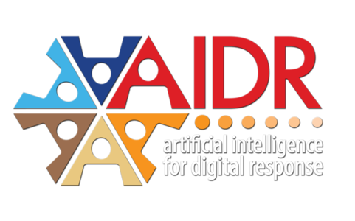
Similar Tools

Artificial Intelligence for Digital Response

AIDR is a platform developed by the Qatar Computing Research Institute, used to filter and classify social media messages from different emergencies, disasters and humanitarian crises.

Red Cross 510
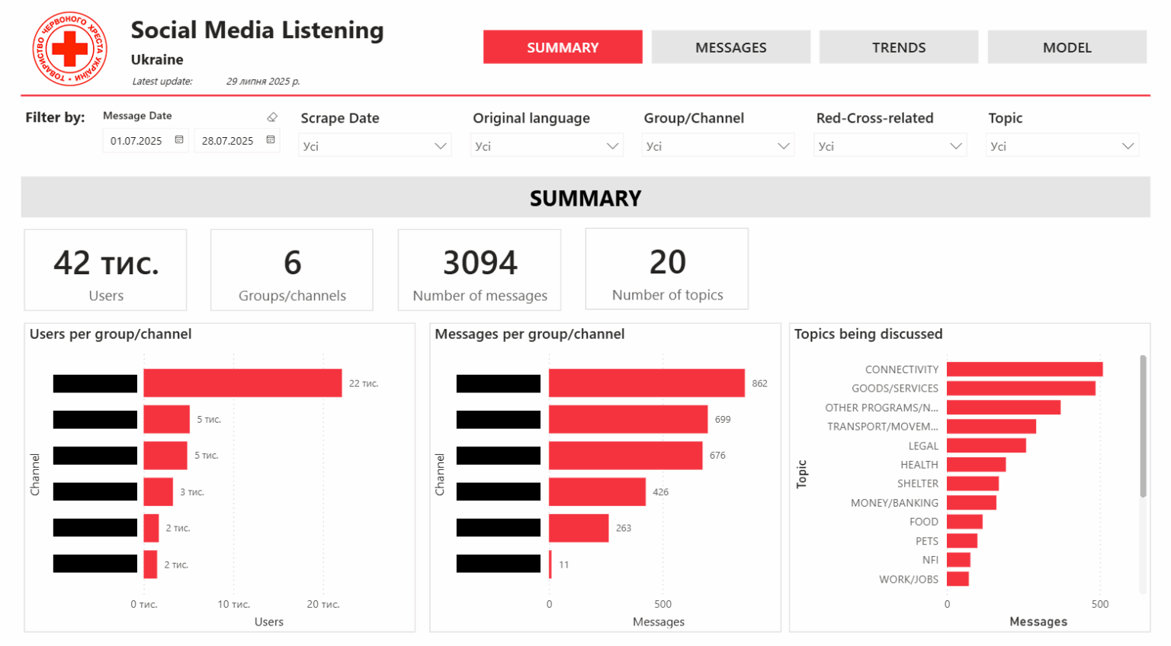
This is a Social Media Listening tool that collects and analyzes crisis messages. The AI Crisis Help Classification model could be used in combination with this tool to assign labels.

Resources
Red Cross. (n.d.). Rode Kruise. https://www.rodekruis.nl/en/
IFRC. (n.d.). IFRC. https://www.ifrc.org/who-we-are/about-ifrc
List of Red Cross and Red Crescent societies. (2025, November 16). Wikipedia. https://en.wikipedia.org/wiki/List_of_Red_Cross_and_Red_Crescent_societies
Social Media Listening in Ukraine: Locally Led Insights, Real Time Response. (n.d.). The Netherlands Red Cross - 510. https://510.global/2025/09/social-media-listening-in-ukraine-locally-led-insights-real-time-response/
MSF Listen: A digital platform to monitor health misinformation in the field. (2022, May 1). Medecins Sans Frontieres. https://www.msf-siu.org/blog/tackling-the-information-disorder
How the Red Cross Uses Social Media for Disaster Response and Engaging Donors. (2015, April 21). Medium. https://medium.com/salesforce-on-marketing/how-the-red-cross-uses-social-media-for-disaster-response-and-engaging-donors-9e4e2f7d2477
MSF URGENT MEDICAL RESPONSE. (n.d.). Médecins Sans Frontières / Doctors Without Borders. https://msf.org.uk/urgent-medical-response

